Classification by Summary Report (355)

The Classification by Summary report consists of the following tables and detailed reports:
- Direct Appeals – Civil Filings
- Civil Classification Detail
- Direct Appeals – Criminal Filings
- Criminal Classification Detail

The report will prompt for a Begin and End date and then query the database to generate the tables and detailed reports shown below.

Direct Appeals – Civil Filings Table
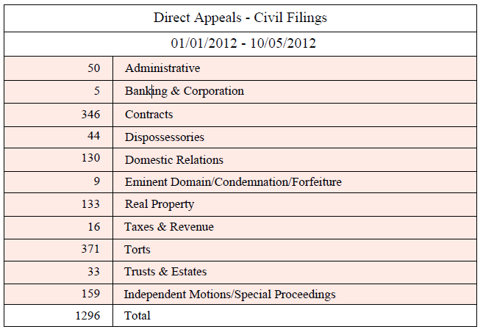

Selected Fields
This report joins the Court Case and Filing tables to select the following:
- Count (Case Number)

Selection Criteria
The report selects records with the following criteria:
- Filing Date and Time - between the Begin and End date parameters.
- Cast Type = A
- Criminal Civil Type = 1
- Classification code is one of the following:

Administrative: (049, 058, 068, 080, 094, 100, 125, 160, 162, 195, 197, 200, 215, 237, 238)
Banking & Corporation: (113, 146, 183, 189, 206, 207, 217, 219,)
Contracts:(009, 010, 011, 012, 013, 014, 016, 017, 018, 019, 020, 021, 022, 023, 024, 025, 026, 027, 028, 029, 030, 031, 032, 055,078, 085, 089, 117, 118, 125, 139, 142, 153, 157, 163, 168, 171, 218, 224, 225, 233)
Dispossessories:(053, 076)
Domestic Relations: (054, 056, 070, 071, 075, 098, 108, 116, 124, 140, 141, 155, 170, 176, 208, 231, 243, 268, 376, 377,)
Eminent Domain/Condemnation/Forfeiture:(050, 065, 166)
Real Property:(052, 057, 082, 083, 092, 096, 109, 110, 111, 126, 128, 132, 152, 172, 178, 185, 190, 220, 235)
Taxes & Revenue: (095, 103, 145, 156)
Torts: (003, 004, 005, 006, 007, 008, 033, 034, 035, 036, 037, 038, 039, 040, 041, 042, 043, 044, 045, 046, 047, 048, 062, 063, 067, 069, 072, 074, 079, 086, 087, 090, 093, 105, 106, 121, 123, 131, 133, 136, 147, 148, 149, 174, 180, 181, 182, 186, 187, 203, 209, 213, 221, 222, 223, 234, 266, 269, 367, 375)
Trusts & Estates: (081, 084, 099, 114, 150, 154, 216)
Independent Motion/Special Proceedings: (000, , 059, 060, 061, 066, 073, 077, 088, 091, 097, 101, 102, 104, 107, 112, 115, 119, 120, 122, 129, 130, 134, 135, 137, 138, 143, 144, 151, 158, 159, 161, 164, 165, 169, 173, 175, 177, 179, 184, 188, 191, 192, 193, 194, 196, 198, 201, 202, 204, 205, 210, 211, 212, 214, 226, 227, 228, 229, 230, 232, 236, 239, 240, 241, 242, 244, 250, 265, 365, 368, 369, 370, 371, 532,)

Civil Classification Detail

Selected Fields
This report joins the Court Case, Filing, and Classifications tables to selects the following:
- Classification
- Code
- Description

Selection Criteria
The report selects records with the following criteria:
- Filing Date and Time - between the Begin and End date parameters.
- Cast Type = A
- Criminal Civil Type = 1
- Classification is one of the following:

000, 003, 004, 005, 006, 007, 008, 009, 010, 011, 012, 013, 014, 016, 017, 018, 019, 020, 021, 022, 023, 024, 025, 026, 027, 028, 029, 030, 031, 032, 033, 034, 035, 036, 037, 038, 039, 040, 041, 042, 043, 044, 045, 046, 047, 048, 049, 050, 052, 053, 054, 055, 056, 057, 058, 059, 060, 061, 062, 063, 065, 066, 067, 068, 069, 070, 071, 072, 073, 074, 075, 076, 077, 078, 079, 080, 081, 082, 083, 084, 085, 086, 087, 088, 089, 090, 091, 092, 093, 094, 095, 096, 097, 098, 099, 100, 101, 102, 103, 104, 105, 106, 107, 108, 109, 110, 111, 112, 113, 114, 115, 116, 117, 118, 119, 120, 121, 122, 123, 124, 125, 126, 128, 129, 130, 131, 132, 133, 134, 135, 136, 137, 138, 139, 140, 141, 142, 143, 144, 145, 146, 147, 149, 150, 151, 152, 153, 154, 155, 156, 157, 158, 159, 160, 161, 162, 163, 164, 165, 166, 168, 169, 170, 171, 172, 173, 174, 175, 176, 177, 178, 179, 180, 181, 182, 183, 184, 185, 186, 187, 188, 189, 190, 191, 192, 193, 194, 195, 196, 197, 198, 200, 201, 202, 203, 204, 205, 206, 207, 208, 209, 210, 211, 212, 213, 214, 215, 216, 217, 218, 219, 220, 221, 222, 223, 224, 225, 226, 227, 228, 229, 230, 231, 232, 233, 234, 235, 236, 237, 238, 239, 240, 241, 242, 243, 244, 250, 265, 266, 268, 269, 365, 367, 368, 369, 370, 371, 375, 376, 377,

Example:

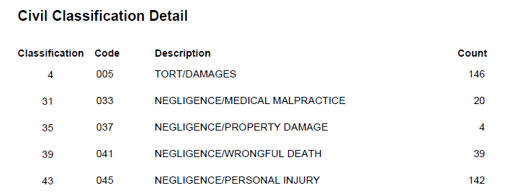
Continued…

Direct Appeals Filings Table
Note: Aggravated Assault in table below should be Aggravated Assault/Battery

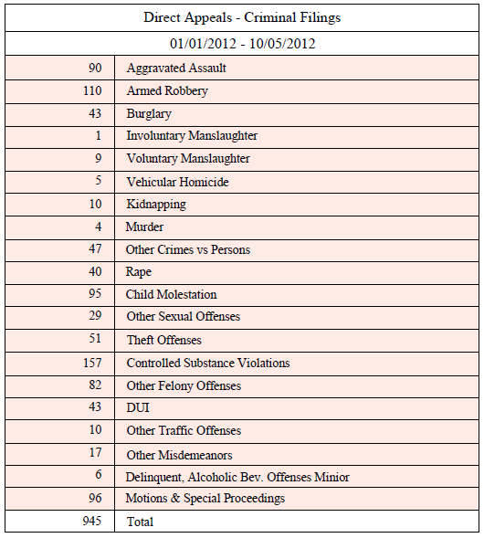

Selected Fields
This report joins the Court Case and Filing tables to select the following:
- Count(Case Number)

Selection Criteria
The report selects records with the following criteria:
- Filing Date and Time - is between the Begin and End date parameters.
- CaseType = A
- Criminal Civil Type = 0
- Classification code is one of the following:
Aggravated Assault/Battery: (507, 555)
Armed Robbery: (502)
Burglary: (501)
Involuntary Manslaughter: (506)
Voluntary Manslaughter: (533)
Vehicular Homicide: (542)
Kidnapping: (504)
Murder: (510, 539,632)
Other Crimes vs Persons: (127 ( this is a civil case code number ), 511, 534, 555, 558, 599, 602, 609, 650, 656, 662, , 683, 688)
Rape: (503)
Child Molestation: (508)
Other Sexual Offenses: (509, 518, 528, 552, 588, 589, 636, 648, 668)
Theft Offenses: (513, 514, 525, 545, 553, 554, 572, 611, 613, 637, 653)
Controlled Substance Violations: (500, 543, 548, 639)
Other Felony Offenses: (189, 516, 519, , 530, 537, 538, 540, 541, 560, 562, 563, 568, 569, 578, 579, 580, 583, 584, 585, 587, 593, 600, 601, 603, 606, 610, 615, 616, 618, 620, 623, 624, 625, 630, 631, 633, 635, 641, 646, 651, 654, 660, 663, 664, 665, 669, 671, 672, 673, 674, 675, 682, 684, 686, 687, 690, 691, 692)
DUI: (505, 517)
Other Traffic Offenses: (521, 529, 608, 642, 676, 685)
Other Misdemeanors: (515,522, 526, 527, 535, 536, 547, 549, 557, 566, 570, 574, 591, 592, 595, 596, 598, 607, 612, 617, 619, 621, 622, 629, 638, 640, 645, 647, 655, 661, 670, 677, 681, 689)
Delinquent, Alcoholic Bev. Offenses Minor: (524, 531, 567, 689)
Motions & Special Proceedings: (512, 520, 523, 532, 544, 546, 550, 551, 556, 559, 561, 564, 565, 571, 573,575, 576, 577, 581, 582, 586, 590, 594, 604, 605, 614, 626, 627, 628, 634, 643, 644, 649, 652, 657, 658, 659, 666, 667, 678, 680, 681)

Criminal Classification Detail

Selected Fields
This report joins the Court Case, Filing, and Classifications tables to select the following:
- Classification
- Code
- Description

Selection Criteria
The report selects records with the following criteria:
- Filing Date and Time - between the Begin and End date parameters.
- Case Type = A
- Criminal Civil Type = 0
- Classification is one of the following:

500, 501, 502, 503, 504, 505, 506, 507, 508, 509, 510, 511, 512, 513, 514, 515, 516, 517, 518, 519, 520, 521, 522, 523, 524, 525, 526, 527, 528, 529, 530, 531, 532, 533, 534, 535, 536, 537, 538, 539, 540, 541, 542, 543, 544, 545, 546, 547, 548, 549, 550, 551, 552, 553, 554, 555, 556, 557, 558, 559, 560, 561, 562, 563, 564, 565, 566, 567, 568, 569, 570, 571, 572, 573, 574, 575, 576, 577, 578, 579, 580, 581, 582, 583, 584, 585, 586, 587, 588, 589, 590, 591, 592, 593, 594, 595, 596, 598, 599, 600, 601, 602, 603, 604, 605, 606, 607, 608, 609, 610, 611, 612, 613, 614, 615, 616, 617, 618, 619, 620, 621, 622, 623, 624, 625, 626, 627, 628, 629, 630, 631, 632, 633, 634, 635, 636, 637, 638, 639, 640, 641, 642, 643, 644, 645, 646, 647, 648, 649, 650, 651, 652, 653, 654, 655, 656, 657, 658, 659, 660, 661, 662, 663, 664, 665, 666, 667, 668, 669, 670, 671, 672, 673, 674, 675, 676, 677, 678, 680, 681, 682, 683, 684, 685, 686, 687, 688, 689, 690, 691, 692
Example:
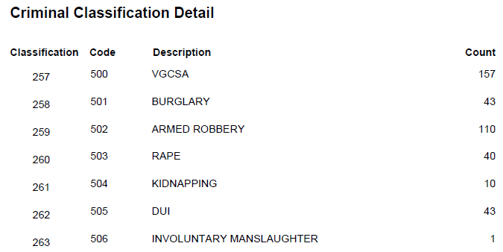
Continued…

